
School of Computing
Department of Computer Science and Engineering
ACADEMIC YEAR: 2025-26
(WINTER SEMESTER)

LAB RECORD

10211CS224 - Full Stack Application Development

NAME : THUPATI GAGAN
VTU.NO : 27292
REG.NO : 23UECS0572
BRANCH : COMPUTER SCIENCE AND ENGINEERING
YEAR/SEM : 3rd/ Vl
SLOT : E2

10211CS224 - Full Stack Application Development
TABLE OF CONTENTS
Task No | Date | Experiment Title
 | 06-01-2026 | Student Registration System with Database Storage and Retrieval
 | 07-01-2026 | Data Retrieval, Sorting, and Filtering Dashboard
 | 28-01-2026 | Login System with Input Validation and Authentication
 | 03-02-2026 | Order Management Using SQL Joins and Subqueries
 | 04-02-2026 | Transaction-Based Payment Simulation Using COMMIT and ROLLBACK
 | 10-02-2026 | Automated Logging Using Database Triggers and Views
 | 12-02-2026 | Interactive Web Form Using JavaScript Events and Functions
 | 17-02-2026 | Employee Management Using Spring Core and Dependency Injection
 | 18-02-2026 | Spring MVC Application Using Annotation-Based Configuration
 | 25-02-2026 | Student CRUD Operations Using Spring Boot and JPA
 | 26-02-2023 | Data Access Using Spring Data JPA with Sorting and Pagination
 | 03-02-2026 | RESTful API for Product Management Using Spring Boot
 | 04-03-2026 | Exception Handling and Validation in RESTful Applications
 | 10-03-2026 | Microservices Architecture with Service Decomposition
 | 11-03-2026 | Service Registry and Discovery Using Eureka
 | 17-03-2026 | API Gateway with Load Balancing for Microservices
 | 18-03-2026 | Inter-Service Communication Using REST APIs
 | 24-03-2026 | Unit Testing for Microservices Applications
 | 28-03-2026 | Version Control Using Git and Remote Repositories
 | 01-04-2026 | Git Branching, Merging, and Conflict Resolution
 | 08-04-2026 | CI/CD Pipeline for Automated Build and Deployment
 | 15-04-2026 | Cloud Service Providers Comparison and Pricing Models
 | 21-04-2026 | Prompt Engineering for Code Generation Using Generative AI
 | 28-04-2026 | Cloud-Based Application Using Vibe Coding and Generative AI
 | 29-04-2026 | Use Cases

TASK-1 : Student Registration & Data Storage
Aim : To create a Student Registration Form using HTML5 and CSS3 and store the data in a database, then retrieve it using SELECT query.
Procedure
- Create an HTML form using HTML5
- Style the form using CSS3
- Create a database and table in MySQL
- Use a backend language (PHP) to store form data
- Retrieve stored data using SELECT query
- Display the result in browser.
Program:
form.html
<!DOCTYPE html>
<html>
<body>
<form action="insert.php" method="post">
Name: <input type="text" name="name"><br>
Email: <input type="email" name="email"><br>
DOB: <input type="date" name="dob"><br>
Dept: <input type="text" name="dept"><br>
Phone: <input type="text" name="phone"><br>
<button type="submit">Submit</button>
</form>
</body>
</html>
insert.php
<?php
$conn = new mysqli("localhost", "root", "", "studentdb", 3308);
$name = $_POST['name'];
$email = $_POST['email'];
$dob = $_POST['dob'];
$dept = $_POST['dept'];
$phone = $_POST['phone'];
$sql = "INSERT INTO students(name,email,dob,dept,phone)
VALUES('$name','$email','$dob','$dept','$phone')";
if($conn->query($sql)==TRUE){
echo "Data inserted successfully";
}else{
echo "Error";
}
?>
select.php
<?php
$conn = new mysqli("localhost", "root", "", "studentdb", 3308);
$result = $conn->query("SELECT * FROM students");
while($row = $result->fetch_assoc()){
echo $row['name']." - ".$row['email']."<br>";
}
?>
http://localhost/student/form.html

Outputs:
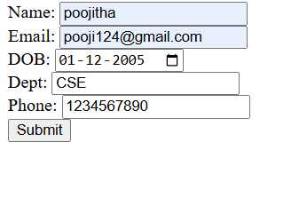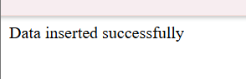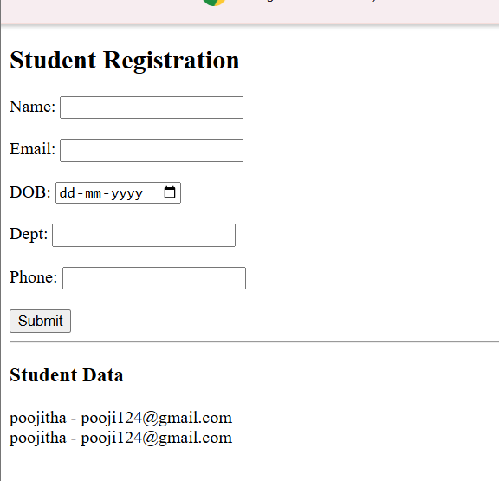
Result : The student registration system was successfully developed to store and manage student data using a web interface and MySQL database.

TASK-2 :
Aim :
To develop a web-based dashboard that allows users to store, retrieve, and display student data efficiently from a database, and present it in a structured format for easy access and management.
ALGORITHM:
- Connect to database using PHP
- Retrieve student data from table
- Apply sorting (name/date)
- Apply filtering (department)
- Count students per department
- Display all in one page

Program :

<?php

$conn = new mysqli("localhost", "root", "", "studentdb", 3308);

// Sorting

$order = "";

if(isset($_GET['sort'])){

if($_GET['sort'] == "name"){

$order = "ORDER BY name";

}

elseif($_GET['sort'] == "date"){

$order = "ORDER BY dob";

}

}

// Filtering

$where = "";

if(isset($_GET['dept']) && $_GET['dept'] != ""){

$dept = $_GET['dept'];

$where = "WHERE dept='$dept'";

}

// Fetch data

$result = $conn->query("SELECT * FROM students $where $order");

// Count

$count = $conn->query("SELECT dept, COUNT(*) as total FROM students GROUP BY dept");

?>

<!DOCTYPE html>

<html>

<head>

<title>Dashboard</title>

<style>

body {

font-family: Arial;

background: #1f3c4d;

color: white;

text-align: center;

}

.container {

width: 80%;

margin: auto;

padding: 20px;

background: #2f4f63;

border-radius: 10px;

}

h2 {

margin-bottom: 20px;

}

select, button {

padding: 8px;

margin: 5px;

}

button {

background: #ff4d6d;

color: white;

border: none;

cursor: pointer;

}

table {

width: 100%;

margin-top: 20px;

border-collapse: collapse;

}

th {

background: #29465b;

padding: 10px;

}

td {

padding: 10px;

background: #3b5f73;

}

tr:nth-child (even) td {

background: #33576a;

}

.count {

margin-top: 20px;

text-align: left;

}

</style>

</head>

<body>

<div class="container";

<h2>Student Dashboard</h2>

<form method="get">

<select name="sort">

<option value="">Sort By</option>

<option value="name">Name</option>

<option value="date">DOB</option>

</select>

<select name="dept">

<option value="">Filter by Department</option>

<option>CSE</option>

<option>IT</option>

<option>ECE</option>

<option>EEE</option>

</select>

<button type="submit">Apply</button>

</form>

<table border="1">

<tr>

<th>ID</th>

<th>Name</th>

<th>Email</th>

<th>DOB</th>

<th>Department</th>

<th>Phone</th>

</tr>

<?php

while($row = $result->fetch_assoc()){

echo "<tr>

<td>{$row['id']}</td>

<td>{$row['name']}</td>

<td>{$row['email']}</td>

<td>{$row['dob']}</td>

<td>{$row['dept']}</td>

<td>{$row['phone']}</td>

</tr>";

}

?>

</table>

<div class="count">

<h3>Department Count</h3>

<?php

while($row = $count->fetch_assoc()){

echo $row['dept']." : ".$row['total']." Students<br>";

}

?>

</div>

</div>

</body>

</html>
http://localhost/student/dashboard.php
Output :
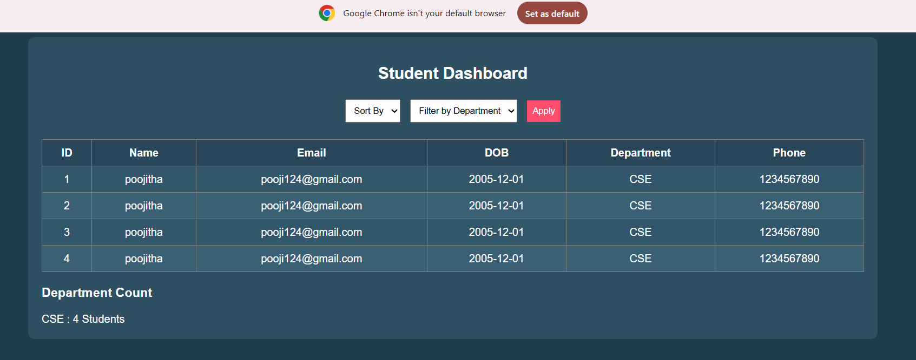
Result : The system successfully stores, retrieves, and displays student data efficiently through a user-friendly dashboard.

TASK-3: Login System with Validation
Aim :
To develop a login system with input validation using JavaScript and check credentials from database.

🔹 Procedure
- Create login form using HTML
- Add validation using JavaScript
- Connect to database using PHP
- Verify username and password
- Show error/success messages dynamically
Program :
Php
<?php
$conn = new mysqli("localhost", "root", "", "studentdb", 3308);
$msg = "";
if(isset($_POST['login'])){
$u = $_POST['username'];
$p = $_POST['password'];
if($u == "" || $p == ""){
$msg = "All fields required";
} else {
$sql = "SELECT * FROM users WHERE username='$u' AND password='$p'";
$res = $conn->query($sql);
if($res->num_rows > 0){
$msg = "Login Successful";
} else {
$msg = "Invalid Login";
}
}
}
?>
<!DOCTYPE html>
<html>
<head>
<title>Login</title>
<script>
function validate(){
var u = document.forms["f"]["username"].value;
var p = document.forms["f"]["password"].value;
if(u=="" || p==""){
alert("Fill all fields");
return false;
}
}
</script>
</head>
<body>
<h2>Login Page</h2>
<form name="f" method="post" onsubmit="return validate()">
<input type="text" name="username" placeholder="Username"><br><br>
<input type="password" name="password" placeholder="Password"><br><br>
<button name="login">Login</button>
</form>
<p><?php echo $msg; ?></p>
</body>
</html>
Style.css :
<?php
$conn = new mysqli("localhost", "root", "", "studentdb", 3308);
$msg = "";
if(isset($_POST['login'])){
$u = $_POST['username'];
$p = $_POST['password'];
if($u == "" || $p == ""){
$msg = "All fields required";
} else {
$sql = "SELECT * FROM users WHERE username='$u' AND password='$p'";
$res = $conn->query($sql);
if($res->num_rows > 0){
$msg = "Login Successful";
} else {
$msg = "Invalid Login";
}
}
}
?>
<!DOCTYPE html>
<html>
<head>
<title>Login</title>
<link rel="stylesheet" href="style.css">
</head>
<body>
<h2>Login Page</h2>
<form method="post">
<input type="text" name="username" placeholder="Username"><br><br>
<input type="password" name="password" placeholder="Password"><br><br>
<button name="login">Login</button>
</form>
<p><?php echo $msg; ?></p>
</body>
</html>
http://localhost/student/login.php
Outputs :
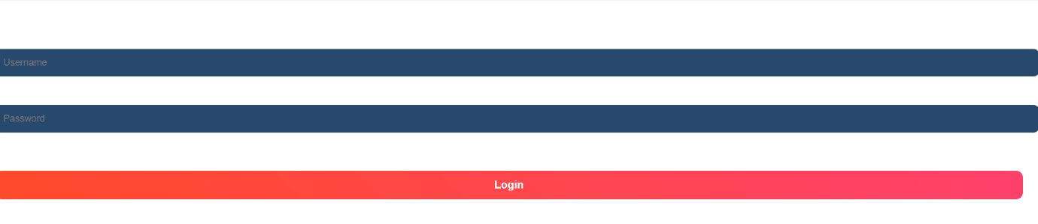
Result :
The system successfully validates user credentials and grants access only to authorized users while preventing invalid logins.

Task-4 :
Aim :
To manage orders by retrieving data from multiple tables using SQL JOIN operations.
Procedure:
- Create a database (studentdb)
- Create tables: Customers and Orders
- Insert sample data into both tables
- Use JOIN query to combine data
- Display the result using PHP.
Program:
Php
<?php
$conn = new mysqli("localhost", "root", "", "studentdb", 3308);
// Add Customer
if(isset($_POST['add_customer'])){
$name = $_POST['cname'];
$email = $_POST['email'];
$conn->query("INSERT INTO customers (name,email) VALUES ('$name','$email')");
}
// Place Order
if(isset($_POST['place_order'])){
$cid = $_POST['customer'];
$pid = $_POST['product'];
$price = $conn->query("SELECT price FROM products WHERE id=$pid")->fetch_assoc()['price'];
$conn->query("INSERT INTO orders (customer_id, product, amount)
VALUES ($cid, (SELECT name FROM products WHERE id=$pid), $price)");
}
// Fetch Data
$customers = $conn->query("SELECT * FROM customers");
$products = $conn->query("SELECT * FROM products");
$orders = $conn->query("SELECT customers.name, orders.product, orders.amount
FROM customers
JOIN orders ON customers.id = orders.customer_id");
$highest = $conn->query("SELECT * FROM orders ORDER BY amount DESC LIMIT 1")->fetch_assoc();
?>
<!DOCTYPE html>
<html>
<head>
<title>Order Dashboard</title>
<link rel="stylesheet" href="style.css">
</head>
<body>
<div class="container">
<h2>Order Management Dashboard</h2>
<!-- Add Customer -->
<h3>Add Customer</h3>
<form method="post">
<input type="text" name="cname" placeholder="Customer Name" required>
<input type="email" name="email" placeholder="Email" required>
<button name="add_customer">Add Customer</button>
</form>
<!-- Place Order -->
<h3>Place Order</h3>
<form method="post">
<select name="customer">
<?php while($c = $customers->fetch_assoc()){ ?>
<option value="<?= $c['id'] ?>"><?= $c['name'] ?></option>
<?php } ?>
</select>
<select name="product">
<?php while($p = $products->fetch_assoc()){ ?>
<option value="<?= $p['id'] ?>"><?= $p['name'] ?></option>
<?php } ?>
</select>
<button name="place_order">Place Order</button>
</form>
<!-- Order History -->
<h3>Order History</h3>
<table>
<tr><th>Customer</th><th>Product</th><th>Amount</th></tr>
<?php while($o = $orders->fetch_assoc()){ ?>
<tr>
<td><?= $o['name'] ?></td>
<td><?= $o['product'] ?></td>
<td><?= $o['amount'] ?></td>
</tr>
<?php } ?>
</table>
<!-- Highest Order -->
<h3>Highest Order</h3>
<p style="color:white;">
₹ <?= $highest['amount'] ?> (Order ID: <?= $highest['id'] ?>)
</p>
</div>
</body>
</html>
Style.css :
<?php
$conn = new mysqli("localhost", "root", "", "studentdb", 3308);
$sql = "SELECT customers.name, customers.email, orders.product, orders.amount
FROM customers
JOIN orders ON customers.id = orders.customer_id";
$result = $conn->query($sql);
?>
<!DOCTYPE html>
<html>
<head>
<link rel="stylesheet" href="style.css">
ss
<title>Order Dashboard</title>
<link rel="stylesheet" href="style.css">
</head>
<body>
<div class="container">
<h2>Order Management Dashboard</h2>
<!-- Buttons -->
<div style="text-align:center; margin-bottom:15px;">
<a href="#" class="btn">Add Order</a>
<a href="#" class="btn">Refresh</a>
</div>
<table>
<tr>
<th>Name</th>
<th>Email</th>
<th>Product</th>
<th>Amount</th>
</tr>
<?php
while($row = $result->fetch_assoc()){
echo "<tr>
<td>{$row['name']}</td>
<td>{$row['email']}</td>
<td>{$row['product']}</td>
<td>{$row['amount']}</td>
</tr>";
}
?>
</table>
</div>
</body>
</html>
Output :
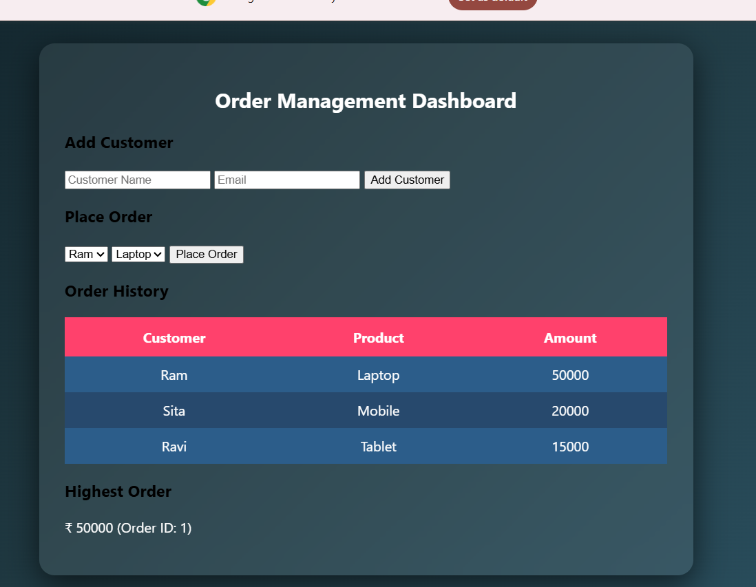
Result :
The system successfully retrieves and analyzes customer order data using joins and subqueries, displaying meaningful insights like highest order value and most active customer.

Task-5 :
Aim:
To simulate an online payment system using database transactions that ensures safe and reliable fund transfer between user and merchant accounts using COMMIT and ROLLBACK operations.
Alogorithm :
- Start
- Read number of users N
- For each user:
  - Input UserID, Name, Balance
  - Store in data structure
- Read number of transactions T
- For each transaction:
  - Input SenderID, ReceiverID, Amount
  - If Amount <= 0 → Print "Invalid Amount"
  - If SenderID == ReceiverID → Print "Self-payment not allowed"
  - If user not found → Print "Invalid User"
  - If sender balance < amount → Print "Insufficient Balance"
  - Else:
    - Deduct amount from sender
    - Add amount to receiver
    - Print "Transaction Successful"
- Display final balances
- Stop.

Program :
}
button:hover{
background:darkgreen;
}
h3{
margin:5px;
color:#333;
}
Output:
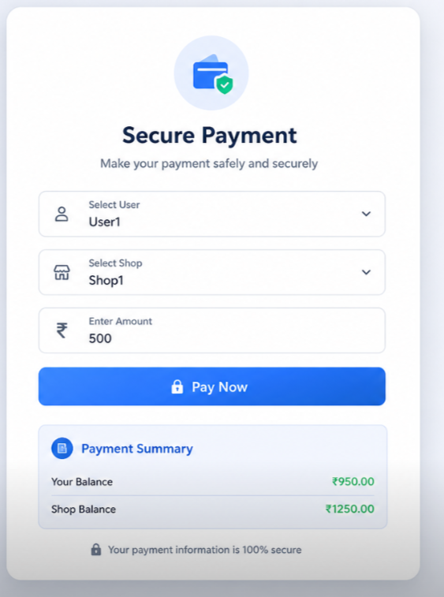
Result :
The system successfully performs secure payment transactions by updating balances accurately using COMMIT on success and ROLLBACK on failure.

Task-6 : Automated Logging using Triggers & Views
Aim :
To develop a web-based application for automated logging of database activities using MySQL triggers and views, integrated with a Node.js backend and frontend interface, in order to track INSERT and UPDATE operations and generate daily activity reports.
Procedure :
1. Start the program
2. Create database and required tables
3. Create triggers for INSERT and UPDATE operations
4. Store actions in log table automatically
5. Create a view for daily activity report
6. Develop backend using Node.js and Express
7. Connect backend with MySQL database
8. Create APIs for add, update, logs, and report
9. Design frontend using HTML, CSS, and JavaScript
10. Run the application and display results
11. Stop the program.
Program :
DROP TABLE IF EXISTS employee_log;
DROP TABLE IF EXISTS employees;
-- Create employees table
CREATE TABLE employees (
emp_id INT AUTO_INCREMENT PRIMARY KEY,
name VARCHAR(50),
salary INT
);
-- Create log table
CREATE TABLE employee_log (
log_id INT AUTO_INCREMENT PRIMARY KEY,
emp_id INT,
action_type VARCHAR(10),
action_time TIMESTAMP DEFAULT CURRENT_TIMESTAMP
);
-- Trigger for INSERT
DELIMITER $$
CREATE TRIGGER trg_insert
AFTER INSERT ON employees
FOR EACH ROW
BEGIN
INSERT INTO employee_log(emp_id, action_type)
VALUES (NEW.emp_id, 'INSERT');
END$$
-- Trigger for UPDATE
CREATE TRIGGER trg_update
AFTER UPDATE ON employees
FOR EACH ROW
BEGIN
INSERT INTO employee_log(emp_id, action_type)
VALUES (NEW.emp_id, 'UPDATE');
END$$
-- Trigger for DELETE
CREATE TRIGGER trg_delete
AFTER DELETE ON employees
FOR EACH ROW
BEGIN
INSERT INTO employee_log(emp_id, action_type)
VALUES (OLD.emp_id, 'DELETE');
END$$
DELIMITER ;
-- Create view
CREATE VIEW log_view AS
SELECT * FROM employee_log;
-- Sample operations
INSERT INTO employees(name, salary) VALUES ('Alice', 50000);
UPDATE employees SET salary = 60000 WHERE emp_id = 1;
DELETE FROM employees WHERE emp_id = 1;
-- Output
SELECT * FROM log_view;
STYLE.CSS:
body { font-family: Arial;
text-align: center; background: #f4f4f4;
}
.form { margin: 15px;
}
input { padding: 8px;
margin: 5px;
} button { padding: 8px 15px;
background: blue;
color: white;
border: none;
cursor: pointer;
}
button:hover { background: darkblue;
}
pre { background: white; padding: 10px;
width: 60%;
margin: auto; text-align: left;
}
Output :
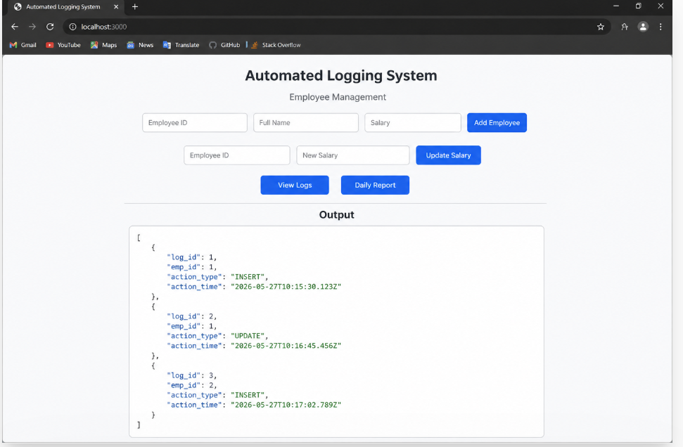
Result :
The system successfully logs all INSERT and UPDATE operations automatically using triggers and displays daily activity reports through a web interface.

Task-7 : Interactive Web Form with Events & Functions
Aim :
To develop an interactive web-based feedback form with real-time validation, UI effects, and backend data storage using HTML, CSS, JavaScript, and Node.js.
Procedure :
1. Start the program
2. Create project files (HTML, CSS, JS, server.js, db.js)
3. Design feedback form with input fields (name, email, message)
4. Apply CSS styling for layout and visual effects
5. Define reusable validation functions in JavaScript
6. Capture user input using DOM elements
7. Apply keyup event for real-time validation
8. Add hover effect to highlight input fields
9. Implement double-click event on submit button
10. Validate all fields before submission
11. Send data to server using fetch API (POST request)
12. Store data in database module and display success message.
PROGRAM:
<!DOCTYPE html>
<html>
<head>
<title>Interactive Web Form</title>
<style>
body {
font-family: Arial;
text-align: center;
background: #f2f2f2;
}
.container {
margin-top: 50px;
background: white;
padding: 20px;
width: 300px;
margin-left: auto;
margin-right: auto;
border-radius: 10px;
box-shadow: 0 0 10px gray;
}
input {
width: 90%;
padding: 8px;
margin: 8px;
}
button {
padding: 10px 15px;
background: blue;
color: white;
border: none;
cursor: pointer;
}
#output {
margin-top: 20px;
font-weight: bold;
}
</style>
</head>
<body>
<div class="container">
<h2>Employee Form</h2>
<input type="text" id="name" placeholder="Enter Name"><br>
<input type="number" id="salary" placeholder="Enter Salary"><br>
<button onclick="addEmployee()">Add</button>
<button onclick="clearForm()">Clear</button>
<div id="output"></div>
</div>
<script>
function addEmployee() {
let name = document.getElementById("name").value;
let salary = document.getElementById("salary").value;
if(name === "" || salary === "") {
alert("Please fill all fields!");
return;
}
document.getElementById("output").innerHTML =
"Employee Added: " + name + " | Salary: " + salary;
}
function clearForm() {
document.getElementById("name").value = "";
document.getElementById("salary").value = "";
document.getElementById("output").innerHTML = "";
}
// Event Example (on change)
document.getElementById("salary").addEventListener("change", function() {
alert("Salary Entered: " + this.value);
});
</script>
</body>
</html>
STYLE.CSS:
body
{
font-family: 'Segoe UI', sans-serif;
background: linear-gradient(135deg, #1f1c2c, #928dab);
display: flex;
justify-content: center;
align-items: center;
height: 100vh;
color: white;
}
.container { background: rgba(255, 255, 255, 0.1);
padding: 25px;
border-radius: 15px;
backdrop-filter: blur(10px);
width: 320px;
box-shadow: 0 10px 25px rgba(0,0,0,0.3);
}
h2 { text-align: center;
}
input, textarea { width: 100%; padding: 10px;
margin: 8px 0;
border-radius: 8px;
border: none;
outline: none;
transition: 0.3s;
}
input:hover, textarea:hover {
transform: scale(1.05);
box-shadow: 0 0 8px #00f7ff;
}bottom{
width: 100%;
padding: 10px;
background: #00c6ff;
border: none;
border-radius: 10px;
color: white;
font-weight: bold;
cursor: pointer;
} button:hover {
background: #0072ff;
} .error {
color: #ff6b6b;
font-size: 12px;
} #successMsg { text-align: center;
margin-top: 10px;
color: #00ffae;
}
Output :
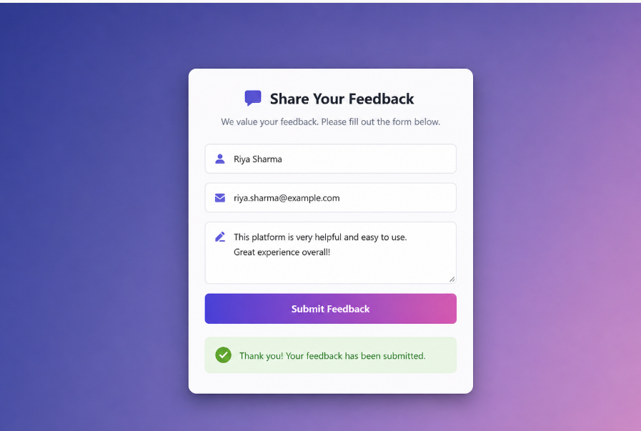
Result :
The interactive feedback form was successfully implemented with real-time validation, enhanced UI effects, and backend data handling.

Task-8 : Employee Management
Aim :
To develop a simple Employee Management system using HTML, CSS, JavaScript, and Node.js for adding and displaying employee data.
Alogorithm :
1.Start the program
2. Create project files (HTML, CSS, JS, server.js, db.js)
3. Design the user interface with input fields (name, role)
4. Apply CSS styling for layout and centering
5. Capture user input using JavaScript
6. Create function to add employee data
7. Send data to server using fetch API (POST request)
8. Create backend using Node.js and Express
9. Receive and store employee data in memory (db.js)
10. Create API to fetch all employee records (GET request)
11. Display employee list dynamically on the webpage
12. Stop the program.
Program :
<!DOCTYPE html>
<html>
<head>
<title>Employee Management</title>
<style>
body {
margin: 0;
font-family: Arial;
background: linear-gradient(135deg, #4e54c8, #8f94fb);
display: flex;
justify-content: center;
align-items: center;
height: 100vh;

.card {
background: #fff;
padding: 25px;
border-radius: 12px;
width: 350px;
box-shadow: 0 10px 25px rgba(0,0,0,0.2);
text-align: center;
}
h2 {
margin-bottom: 15px;
}
input {
width: 90%;
padding: 10px;
margin: 8px 0;
border-radius: 6px;
border: 1px solid #ccc;
}
button {
width: 95%;
padding: 10px;
margin-top: 10px;
border: none;
border-radius: 6px;
background: linear-gradient(90deg, #667eea, #764ba2);
color: white;
font-size: 15px;
cursor: pointer;
}
button:hover {
opacity: 0.9;
}
.success {
margin-top: 15px;
color: green;
display: none;
}
.list {
margin-top: 15px;
text-align: left;
font-size: 14px;
}
</style>
</head>
<body>
<div class="card">
<h2>Employee Management</h2>
<input type="text" id="name" placeholder="Enter Name">
<input type="number" id="salary" placeholder="Enter Salary">
<button onclick="addEmployee()">Add Employee</button>
<div class="success" id="msg">✔ Employee Added Successfully</div>
<div class="list" id="list"></div>
</div>
<script>
let employees = [];
function addEmployee() {
let name = document.getElementById("name").value;
let salary = document.getElementById("salary").value;
if(name === "" || salary === "") {
alert("Please fill all fields");
return;
}
let emp = {
id: employees.length + 1,
name: name,
salary: salary
};
employees.push(emp);
document.getElementById("msg").style.display = "block";
displayEmployees();
document.getElementById("name").value = "";
document.getElementById("salary").value = "";
}
function displayEmployees() {
let output = "<h4>Employee List:</h4>";
employees.forEach(emp => {
output += "ID: " + emp.id +
" | Name: " + emp.name +
" | Salary: " + emp.salary + "<br>";
});
document.getElementById("list").innerHTML = output;
}
</script>

</body>
</html>
STYLE.CSS:
body
{
font-family: Arial;
background: #1e1e2f;
color: white;
display: flex;
justify-content: center;
align-items: center;
height: 100vh;
margin: 0;
}
.container {
text-align: center;
}
input {
padding: 10px;

margin: 5px;
border-radius: 5px;
border: none;
} button
{ padding: 10px;
background: #00c6ff;
border: none;
border-radius: 5px;
cursor: pointer;
}
SCRIPT.JS:
function addEmployee() {
const name = document.getElementById("name").value;
const role = document.getElementById("role").value;
fetch("http://localhost:3000/add", {
method: "POST",
headers: {
"Content-Type": "application/json"
},
body: JSON.stringify({ name, role })
})
.then(res => res.json())
.then(() => loadEmployees());
}
function loadEmployees() {
fetch("http://localhost:3000/all")
.then(res => res.json()) .then(data => {
let list = document.getElementById("list");
list.innerHTML = "";
data.forEach(emp => {
let li = document.createElement("li");
li.innerText = emp.name + " - " + emp.role;
list.appendChild(li);
});
});
}
loadEmployees();
SERVER.JS:
const express = require("express");
const cors = require("cors");
const path = require("path");
const db = require("./db");
const app = express();
app.use(cors());
app.use(express.json());
app.use(express.static(__dirname));
app.get("/", (req, res) => {
res.sendFile(path.join(__dirname, "index.html"));
});
app.post("/add", (req, res) => {
db.addEmployee(req.body);
res.json({ msg: "Added" });
});
app.get("/all", (req, res) => {
res.json(db.getEmployees());
});
app.listen(3000, () => {
console.log("
});
DB.JS:
let employees = [];
Server running at: http://localhost:3000");
function addEmployee(emp) { employees.push(emp);
}
function getEmployees() {
return employees;
}
module.exports = { addEmployee, getEmployees };
Output:
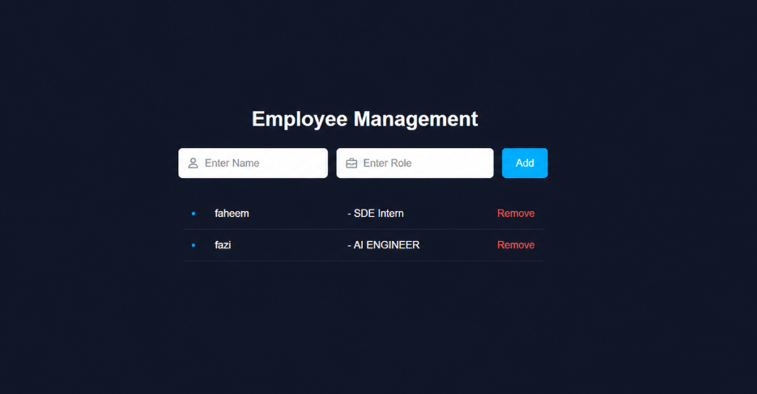
Result :
The Employee Management system was successfully implemented with a user friendly interface and dynamic data handling using Node.js backend.

TASK9: Employee MVC APP
AIM: To develop a basic MVC-based Employee application using HTML, CSS, JavaScript, and Node.js to handle user requests and display employee details.
ALGORITHM:
1. Start the program
2. Create project files (HTML, CSS, JS, server.js, db.js)
3. Design UI form to accept employee details
4. Apply CSS styling for better user interface
5. Capture user input using JavaScript
6. Send request to server using fetch API
7. Create controller logic in server.js
8. Define routes to handle requests (/add, /all)
9. Store employee data in memory using db.js
10. Retrieve employee data from database module
11. Send response back to frontend (view)
12. Display employee details dynamically and stop
Program :
const express = require('express');
const app = express();
app.use(express.urlencoded({ extended: true }));
let employees = [];
function getEmployees() {
return employees;
}
function addEmployee(name, role) {
employees.push({
id: employees.length + 1,
name,
role
});
}
function deleteEmployee(id) {
employees = employees.filter(emp => emp.id != id);
}
function renderPage(res) {
let list = "";
employees.forEach(emp => {
list += `
<li>
${emp.name} - ${emp.role}
<a href="/delete/${emp.id}">Remove</a>
</li>`;
});
res.send(`
<!DOCTYPE html>
<html>
<head>
<title>Employee Management</title>
<style>
body {
margin: 0;
font-family: Arial;
background: #0f172a;
color: white;
display: flex;
justify-content: center;
align-items: center;
height: 100vh;
}
.container {
text-align: center;
}
h2 {
margin-bottom: 20px;
}
input {
padding: 8px;
margin: 5px;
border-radius: 5px;
border: none;
}
button {
padding: 8px 12px;
background: #06b6d4;
border: none;
color: white;
cursor: pointer;
}
ul {
margin-top: 15px;
list-style: none;
padding: 0;
}
li {
margin: 5px 0;
}
a {
color: red;
margin-left: 10px;
text-decoration: none;
}
</style>
</head>
<body>
<div class="container">
<h2>Employee Management</h2>
<form method="POST" action="/add">
<input type="text" name="name" placeholder="Name" required>
<input type="text" name="role" placeholder="Role" required>
<button type="submit">Add</button>
</form>
<ul>
${list}
</ul>
</div>
</body>
</html>
`);
}
app.get('/', (req, res) => {
renderPage(res);
});
app.post('/add', (req, res) => {
const { name, role } = req.body;
if (name && role) {
addEmployee(name, role);
}
res.redirect('/');
});
app.get('/delete/:id', (req, res) => {
deleteEmployee(req.params.id);
res.redirect('/');
});
app.listen(3000, () => {
console.log("Server running at http://localhost:3000");
});
STYLE.CSS:
* {
margin: 0;
padding: 0;
box-sizing: border-box;
}
body {
font-family: 'Segoe UI', sans-serif;
background: linear-gradient(135deg, #1f1c2c, #928dab);
height: 100vh;
display: flex;
justify-content: center;
align-items: center;
color: white;
}
.container {
background: rgba(255, 255, 255, 0.1);
padding: 30px;
border-radius: 15px;
backdrop-filter: blur(10px);
width: 320px;
text-align: center;
box-shadow: 0 10px 25px rgba(0,0,0,0.4);
} h2
{ margin-bottom: 15px;
} input
{
width: 100%;
padding: 10px;
margin: 8px 0;
border: none;
border-radius: 8px;
outline: none;
transition: 0.3s;
} input:hover, input:focus
{
transform: scale(1.05); box-shadow: 0 0 8px #00f7ff;
} button
{
width: 100%;
padding: 10px;
margin-top: 10px;
background: #00c6ff;
border: none; border-radius: 10px;
color: white; f
ont-weight: bold;
cursor: pointer;
transition: 0.3s;
} button:hover
{
background: #0072ff;
transform: scale(1.05);
}
ul { list-style: none;
margin-top: 15px;
} li
{
background: rgba(255,255,255,0.15);
padding: 8px;
margin: 5px 0;
border-radius: 6px;
transition: 0.3s;
} li:hover
{
background: rgba(255,255,255,0.3);
}
Output :
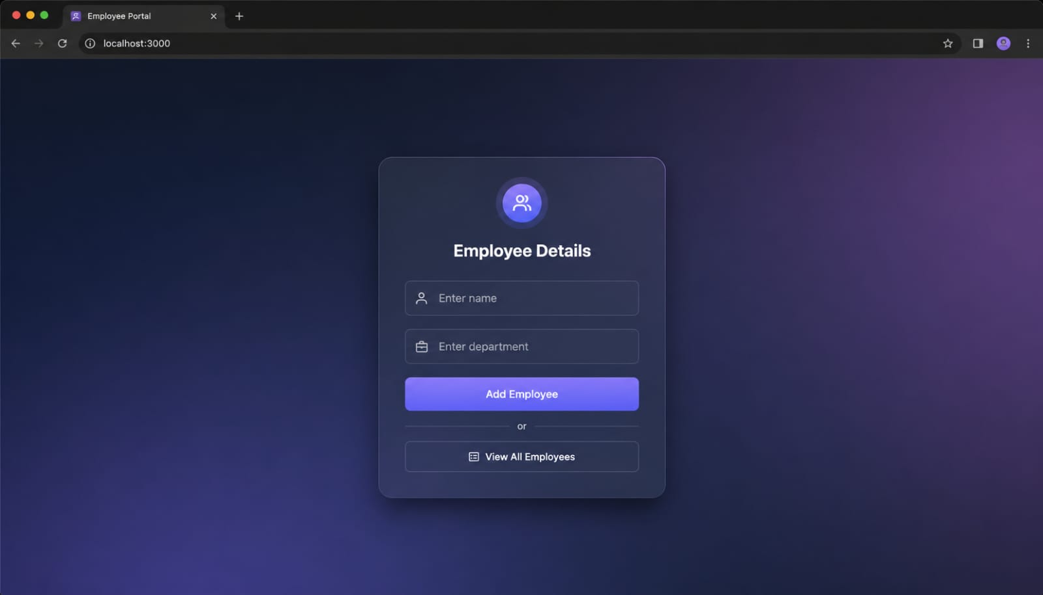
RESULT:
The MVC-based Employee application was successfully implemented using Node.js, where user requests were processed and employee details were displayed dynamically.

TASK10: Student Crud App
AIM: To develop a Student CRUD application using HTML, CSS, JavaScript, and Node.js to perform create, read, update, and delete operations.
ALGORITHM: 1. Start the program
2. Create project files (HTML, CSS, JS, server.js, db.js)
3. Design UI for student input (id, name, course)
4. Apply CSS for styling and layout
5. Capture user input using JavaScript
6. Send data to server using fetch API
7. Create backend using Node.js and Express
8. Implement Create operation (POST request)
9. Implement Read operation (GET request)
10. Implement Update operation (PUT request)
11. Implement Delete operation (DELETE request)
12. Display updated student data dynamically and stop.
PROGRAM:
index.php

<?php
$conn = new mysqli("localhost", "root", "", "student_crud");

if ($conn->connect_error) {
die("Connection failed: " . $conn->connect_error);
}

// CREATE
if (isset($_POST['add'])) {
$name = $_POST['name'];
$email = $_POST['email'];
$course = $_POST['course'];

$conn->query("INSERT INTO students(name,email,course) VALUES('$name','$email','$course')");
}

// DELETE
if (isset($_GET['delete'])) {
$id = $_GET['delete'];
$conn->query("DELETE FROM students WHERE id=$id");
}

// UPDATE
if (isset($_POST['update'])) {
$id = $_POST['id'];
$name = $_POST['name'];
$email = $_POST['email'];
$course = $_POST['course'];

$conn->query("UPDATE students SET name='$name', email='$email', course='$course' WHERE id=$id");
}

// FETCH DATA
$result = $conn->query("SELECT * FROM students");
?>

<!DOCTYPE html>
<html>
<head>
<title>Student CRUD App</title>
<style>
body {
font-family: Arial;
background: #f4f4f4;
text-align: center;
}
.container {
width: 70%;
margin: auto;
background: white;
padding: 20px;
border-radius: 10px;
}
input {
padding: 8px;
margin: 5px;
}
button {
padding: 8px 15px;
background: blue;
color: white;
border: none;
}
table {
width: 100%;
margin-top: 20px;
border-collapse: collapse;
}
table, th, td {
border: 1px solid black;
padding: 10px;
}
a {
text-decoration: none;
color: red;
}
</style>
</head>
<body>

<div class="container">
<h2>Student CRUD App</h2>

<!-- Add Student -->
<form method="POST">
<input type="text" name="name" placeholder="Name" required>
<input type="email" name="email" placeholder="Email" required>
<input type="text" name="course" placeholder="Course" required>
<button name="add">Add Student</button>
</form>

<!-- Display Students -->
<table>
<tr>
<th>ID</th>
<th>Name</th>
<th>Email</th>
<th>Course</th>
<th>Actions</th>
</tr>

<?php while($row = $result->fetch_assoc()) { ?>
<tr>
<form method="POST">
<td><?php echo $row['id']; ?></td>
<td>
<input type="text" name="name" value="<?php echo $row['name']; ?>">
</td>
<td>
<input type="email" name="email" value="<?php echo $row['email']; ?>">
</td>
<td>
<input type="text" name="course" value="<?php echo $row['course']; ?>">
</td>
<td>
<input type="hidden" name="id" value="<?php echo $row['id']; ?>">
<button name="update">Update</button>
<a href="?delete=<?php echo $row['id']; ?>">Delete</a>
</td>
</form>
</tr>
<?php } ?>

</table>
</div>

</body>
</html>
STYLE.CSS:
body {
font-family: 'Segoe UI';
background: linear-gradient(135deg,#1f1c2c,#928dab);
height: 100vh;
display:flex;
justify-content:center;
align-items:center;
color:white;
}
.container {
background: rgba(255,255,255,0.1);
padding:20px;
border-radius:10px;
text-align:center;
}
input {
display:block;
margin:8px auto;
padding:8px;
}
button {
margin:5px;
padding:8px;
background:#00c6ff;
border:none;
color:white;
}
Output :
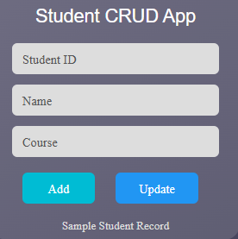
RESULT: The Student CRUD application was successfully implemented with full create, read, update, and delete operations using Node.js and a dynamic web interface.

TASK11: Student Data Layer
AIM: To implement a data access layer for managing student records with filtering, sorting, and pagination using HTML, CSS, JavaScript, and Node.js.
ALGORITHM: 1. Start the program
2. Create project files (HTML, CSS, JS, server.js, db.js)
3. Design UI for student details (id, name, age, department)
4. Apply CSS styling for layout and UI
5. Capture input using JavaScript
6. Send data to backend using fetch API
7. Create Node.js server using Express
8. Store student data in memory (db.js)
9. Implement filtering (by department/age)
10. Implement sorting (by name/age)
11. Implement pagination (limit & page number)
12. Display filtered, sorted, paginated data
Program :
index.php
<?php
$conn = new mysqli("localhost", "root", "", "student_fs");
if ($conn->connect_error) {
die("Connection failed");
}
// ADD STUDENT
if (isset($_POST['add'])) {
$name = $_POST['name'];
$age = $_POST['age'];
$course = $_POST['course'];
$conn->query("INSERT INTO students(name, age, course)
VALUES('$name','$age','$course')");
}
// SEARCH STUDENT
$result = null;
if (isset($_POST['search'])) {
$course = $_POST['scourse'];
$age = $_POST['sage'];
$id = $_POST['sid'];
$result = $conn->query(
"SELECT * FROM students
WHERE course='$course' AND age='$age' AND id='$id'"
);
}
?>
<!DOCTYPE html>
<html>
<head>
<title>Student Data</title>
<style>
body {
background: #1f2235;
font-family: Arial;
color: white;
text-align: center;
}
.container {
width: 300px;
margin: auto;
margin-top: 50px;
}
input {
width: 90%;
padding: 10px;
margin: 8px;
border-radius: 5px;
border: none;
}
button {
padding: 8px 20px;
margin: 10px;
border: none;
border-radius: 5px;
background: #00a8ff;
color: white;
}
.search-btn {
background: #44bd32;
}
.result {
margin-top: 20px;
}
</style>
</head>
<body>
<div class="container">
<h2>Student Data</h2>
<!-- ADD FORM -->
<form method="POST">
<input type="text" name="name" placeholder="Name" required>
<input type="number" name="age" placeholder="Age" required>
<input type="text" name="course" placeholder="Course" required>
<br>
<button name="add">Add</button>
</form>
<hr>
<!-- SEARCH FORM -->
<form method="POST">
<input type="text" name="scourse" placeholder="Course">
<input type="number" name="sage" placeholder="Age">
<input type="number" name="sid" placeholder="ID">
<br>
<button name="search" class="search-btn">Search</button>
</form>
<!-- RESULT -->
<div class="result">
<?php
if ($result && $result->num_rows > 0) {
while($row = $result->fetch_assoc()) {
echo "• " . $row['name'] . " (" . $row['age'] . ") - " . $row['course'];
}
}
?>
</div>
</div>
</body>
</html>
Style.css
/* Page Background */
body {
background: linear-gradient(135deg, #2c2f4a, #1b1e33);
font-family: 'Segoe UI', Arial, sans-serif;
color: #ffffff;
margin: 0;
padding: 0;
}
/* Main Container Card */
.container {
width: 320px;
margin: 80px auto;
background: rgba(255, 255, 255, 0.08);
padding: 25px;
border-radius: 12px;
text-align: center;
box-shadow: 0 8px 25px rgba(0, 0, 0, 0.3);
}
/* Title */
h2 {
margin-bottom: 20px;
font-weight: 600;
}
/* Input Fields */
input {
width: 90%;
padding: 10px;
margin: 8px 0;
border-radius: 6px;
border: none;
outline: none;
background: #e5e7eb;
color: #333;
font-size: 14px;
}
/* Buttons */
button {
padding: 8px 18px;
margin-top: 10px;
border: none;
border-radius: 6px;
background: #00bcd4;
color: white;
cursor: pointer;
font-size: 14px;
transition: 0.3s;
}
button:hover {
background: #0097a7;
}
/* Search Button Different Color */
.search-btn {
background: #4caf50;
}
.search-btn:hover {
background: #388e3c;
}
/* Divider Line */
hr {
margin: 20px 0;
border: 0.5px solid rgba(255, 255, 255, 0.3);
}
/* Result Text */
.result {
margin-top: 15px;
font-size: 15px;
color: #f1f1f1;
}
/* Bullet Style */
.result::before {
content: "";
}
/* Small Screen Responsive */
@media (max-width: 400px) {
.container {
width: 90%;
}
}
Server.js :
const express = require("express");
const bodyParser = require("body-parser");
const cors = require("cors");
const dao = require("./da");
const app = express();
app.use(cors());
app.use(bodyParser.json());
app.use(bodyParser.urlencoded({ extended: true }))
// ADD API
app.post("/add", (req, res) => {
dao.addStudent(req.body, (err, result) => {
if (err) {
res.send("Error adding student");
} else {
res.send("Student Added Successfully");
}
});
});
// SEARCH API
app.post("/search", (req, res) => {
dao.searchStudent(req.body, (err, result) => {
if (err) {
res.send("Error searching");
} else {
res.json(result);
}
});
});
// GET ALL
app.get("/students", (req, res) => {
dao.getAll((err, result) => {
if (err) {
res.send("Error fetching data");
} else {
res.json(result);
}
});
});
// SERVER START
app.listen(3000, () => {
console.log("Server running on http://localhost:3000");
});
DB.js :
const mysql , require("mysql2");
// DB Connection
const db = mysql.createConnection({
host: "localhost",
user: "root",
password: "",
database: "student_fs"
});
db.connect((err) => {
if (err) {
console.log("DB Connection Failed");
} else {
console.log("Connected to MySQL");
}
});
// ADD Student
function addStudent(data, callback) {
const sql = "INSERT INTO students(name, age, course) VALUES (?, ?, ?)";
db.query(sql, [data.name, data.age, data.course], callback);
}
// SEARCH Student
function searchStudent(data, callback) {
const sql = "SELECT * FROM students WHERE course=? AND age=? AND id=?";
db.query(sql, [data.course, data.age, data.id], callback);
}
// GET ALL (optional)
function getAll(callback) {
db.query("SELECT * FROM students", callback);
}
module.exports = {
addStudent,
searchStudent,
getAll
};
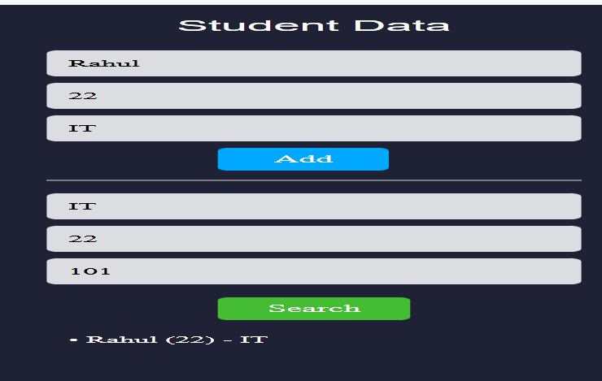
RESULT: The data access layer was successfully implemented with filtering, sorting, and pagination using Node.js and dynamic frontend interaction.

TASK12: Product Api
AIM:
To design and develop a RESTful API for Product Management using Node.js that supports GET, POST, PUT, and DELETE operations with JSON responses.
ALGORITHM:
1. Start the program
2. Create project files (server.js, db.js, HTML, CSS, JS)
3. Design product structure (id, name, price)
4. Create Node.js server using Express
5. Enable JSON parsing using middleware
6. Implement POST method to add products
7. Implement GET method to fetch all products
8. Implement PUT method to update product details
9. Implement DELETE method to remove a product
10. Store product data in memory using db.js
11. Send JSON responses for all API requests
12. Test APIs using browser or REST client.
Program :
index.html
<!DOCTYPE html>
<html>
<head>
<title>Product App</title>
<link rel="stylesheet" href="style.css">
</head>
<body>
<div class="container">
<h2>Product Management</h2>
<input type="text" id="name" placeholder="Product Name">
<input type="number" id="price" placeholder="Price">
<input type="text" id="category" placeholder="Category">
<button onclick="addProduct()">Add</button>
<hr>
<button onclick="getProducts()">Show Products</button>
<div id="output">
</div>
</div>
<script src="script.js">
</script>
</body>
</html>
Style.css:
body {
background: #1e1e2f;
font-family: Arial;
color: white;
text-align: center;
}

.container {
width: 300px;
margin: 80px auto;
background: #2d2d44;
padding: 20px;
border-radius: 10px;
}

input {
width: 90%;
padding: 10px;
margin: 8px;
border-radius: 5px;
border: none;
}

button {
padding: 8px 20px;
margin: 10px;
background: #00bcd4;
color: white;
border: none;
border-radius: 5px;
cursor: pointer;
}

button:hover {
background: #0097a7;
}

#output {
margin-top: 15px;
text-align: left;
}
Script.js :
const API = "http://localhost:3000/product";

// ADD PRODUCT
function addProduct() {
const name = document.getElementById("name").value;
const price = document.getElementById("price").value;
const category = document.getElementById("category").value;

fetch(API, {
method: "POST",
headers: {
"Content-Type": "application/json"
},
body: JSON.stringify({ name, price, category })
})
.then(res => res.text())
.then(data => {
alert(data);
getProducts();
});
}

// GET ALL PRODUCTS
function getProducts() {
fetch(API)
.then(res => res.json())
.then(data => {
let output = "<pre>" + JSON.stringify(data, null, 2) + "</pre>";
document.getElementById("output").innerHTML = output;
});
}
DB.js :
const mysql = require("mysql2");

const db = mysql.createConnection({
host: "localhost",
user: "root",
password: "",
database: "product_db"
});

db.connect(err => {
if (err) console.log("DB Error");
else console.log("MySQL Connected");
});

// ADD
function addProduct(data, cb) {
const sql = "INSERT INTO products(name, price, category) VALUES (?, ?, ?)";
db.query(sql, [data.name, data.price, data.category], cb);
}

// GET ALL
function getProducts(cb) {
db.query("SELECT * FROM products", cb);
}
module.exports = { addProduct, getProducts };
Server.js :
const express = require("express");
const cors = require("cors");

const dao = require("./db");

const app = express();
app.use(cors());
app.use(express.json());

// ADD PRODUCT
app.post("/product", (req, res) => {
dao.addProduct(req.body, (err) => {
if (err) return res.send("Error");
res.send("Product Added");
});
});

// GET PRODUCTS
app.get("/product", (req, res) => {
dao.getProducts((err, data) => {
if (err) return res.send("Error");
res.json(data);
});
});

app.listen(3000, () => {
console.log("Server running at http://localhost:3000");
});
Output :
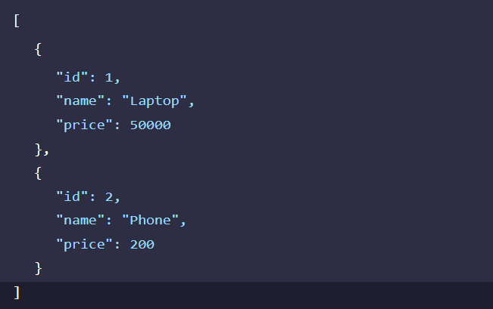
RESULT: The RESTful API for Product Management was successfully implemented with GET, POST, PUT, and DELETE methods returning JSON responses.

TASK13: PRODUCT-API
AIM: To design and develop a RESTful API for Product Management using Node.js that supports GET, POST, PUT, and DELETE operations with JSON responses.
ALGORITHM: 1. Start the program
2. Create project files (server.js, db.js, HTML, CSS, JS)
3. Design product structure (id, name, price)
4. Create Node.js server using Express
5. Enable JSON parsing using middleware
6. Implement POST method to add products
7. Implement GET method to fetch all products
8. Implement PUT method to update product details
9. Implement DELETE method to remove a product
10. Store product data in memory using db.js
11. Send JSON responses for all API requests
12. Test APIs using browser or REST client
Program :
Index.html :
<!DOCTYPE html>
<html>
<head>
<title>PRODUCT API</title>
<link rel="stylesheet" href="style.css">
</head>
<body>
<div class="container">
<h2>Product API</h2>
<!-- ADD PRODUCT -->
<input type="text" id="name" placeholder="Product Name">
<input type="number" id="price" placeholder="Price">
<input type="text" id="category" placeholder="Category">
<button onclick="addProduct()">Add Product</button>
<hr>
<!-- GET ALL -->
<button onclick="getProducts()">View Products</button>
<!-- OUTPUT -->
<div id="output"></div>
</div>
<script src="script.js"></script>
</body>
</html>
Style.css :
body {
background: linear-gradient(135deg, #1e1e2f, #2c2c54);
font-family: Arial;
color: white;
text-align: center;
}

.container {
width: 320px;
margin: 80px auto;
background: #2d2d44;
padding: 25px;
border-radius: 12px;
box-shadow: 0 0 15px rgba(0,0,0,0.5);
}

h2 {
margin-bottom: 15px;
}

input {
width: 90%;
padding: 10px;
margin: 8px;
border-radius: 6px;
border: none;
}

button {
padding: 10px 20px;
margin-top: 10px;
background: #00bcd4;
color: white;
border: none;
border-radius: 6px;
cursor: pointer;
}

button:hover {
background: #0097a7;
}

#output {
margin-top: 20px;
text-align: left;
background: #1e1e2f;
padding: 10px;
border-radius: 8px;
font-size: 13px;
}
Script.js :
const API = "http://localhost:3000/product";

// ADD PRODUCT
function addProduct() {
const name = document.getElementById("name").value;
const price = document.getElementById("price").value;
const category = document.getElementById("category").value;

fetch(API, {
method: "POST",
headers: { "Content-Type": "application/json" },
body: JSON.stringify({ name, price, category })
})
.then(res => res.text())
.then(msg => {
alert(msg);
getProducts();
});
}

// GET PRODUCTS
function getProducts() {
fetch(API)
.then(res => res.json())
.then(data => {
document.getElementById("output").innerHTML =
"<pre>" + JSON.stringify(data, null, 2) + "</pre>";
});
}
DB.js :
const mysql = require("mysql2");

const db = mysql.createConnection({
host: "localhost",
user: "root",
password: "",
database: "product_db"
});

db.connect(err => {
if (err) console.log("DB Connection Failed");
else console.log("MySQL Connected");
});

// CREATE
function addProduct(data, cb) {
const sql = "INSERT INTO products(name, price, category) VALUES (?, ?, ?)";
db.query(sql, [data.name, data.price, data.category], cb);
}

// READ
function getProducts(cb) {
db.query("SELECT * FROM products", cb);
}

module.exports = { addProduct, getProducts };
Output :
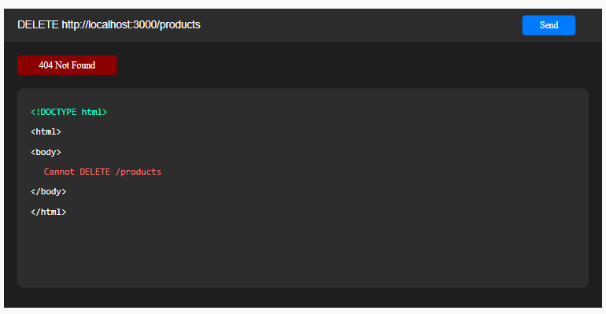
RESULT: The RESTful API for Product Management was successfully implemented with GET, POST, PUT, and DELETE methods returning JSON responses.

TASK14: MICROSERVICES APP
AIM: To design a simple microservices-based system by splitting a monolithic application into independent services with loose coupling and single responsibility.
ALGORITHM: 1. Start the program
2. Identify modules in monolithic system
3. Split system into independent services
4. Create separate folders for each service
5. Implement Service 1 (Product Service)
6. Implement Service 2 (Order Service)
7. Use separate databases (db.js) for each service
8. Assign different ports for each service
9. Enable communication via REST APIs
10. Keep services loosely coupled
11. Deploy and run services independently
12. Access services and verify functionality
Program :
Index.html :
<!DOCTYPE html>
<html>
<head>
<title>Microservices App</title>
<link rel="stylesheet" href="style.css">
</head>
<body>
<div class="container">
<h2>Product Microservice</h2>
<input type="text" id="name" placeholder="Product Name">
<input type="number" id="price" placeholder="Price">
<button onclick="addProduct()">Add</button>
<hr>
<button onclick="getProducts()">View Products</button>
<div id="output"></div>
</div>
<script src="script.js"></script>
</body>
</html>
Style.css :
body {
background: #1e1e2f;
color: white;
font-family: Arial;
text-align: center;
}
.container {
width: 300px;
margin: 80px auto;
background: #2d2d44;
padding: 20px;
border-radius: 10px;
}
input {
width: 90%;
padding: 10px;
margin: 8px;
border: none;
border-radius: 5px;
}
button {
padding: 8px 20px;
margin: 10px;
background: #00bcd4;
color: white;
border: none;
border-radius: 5px;
}
#output {
margin-top: 15px;
text-align: left;
}
Server.js :
const express = require("express");
const dao = require("./db");

const app = express();
app.use(express.json());

// ADD PRODUCT
app.post("/products", (req, res) => {
dao.addProduct(req.body, (err) => {
if (err) return res.send("Error");
res.send("Product Added (Service)");
});
});

// GET PRODUCTS
app.get("/products", (req, res) => {
dao.getProducts((err, data) => {
if (err) return res.send("Error");
res.json(data);
});
});

app.listen(3001, () => {
console.log("Product Service running on port 3001");
});
Script.js :
const API = "http://localhost:3000/products";
function addProduct() {
const name = document.getElementById("name").value;
const price = document.getElementById("price").value;
fetch(API, {
method: "POST",
headers: { "Content-Type": "application/json" },
body: JSON.stringify({ name, price })
})
.then(res => res.text())
.then(msg => {
alert(msg);
getProducts();
});
}
function getProducts() {
fetch(API)
.then(res => res.json())
.then(data => {
document.getElementById("output").innerHTML =
"<pre>" + JSON.stringify(data, null, 2) + "</pre>";
});
}
DB.js :
const mysql = require("mysql2");
const db = mysql.createConnection({
host: "localhost",
user: "root",
password: "",
database: "micro_db"
});
db.connect(err => {
if (err) console.log("DB Error");
else console.log("Product Service DB Connected");
});
function addProduct(data, cb) {
db.query(
"INSERT INTO products(name, price) VALUES (?, ?)",
[data.name, data.price],
cb
);
}
function getProducts(cb) {
db.query("SELECT * FROM products", cb);
}
module.exports = { addProduct, getProducts };
Output :
GET : http://localhost:3001/products
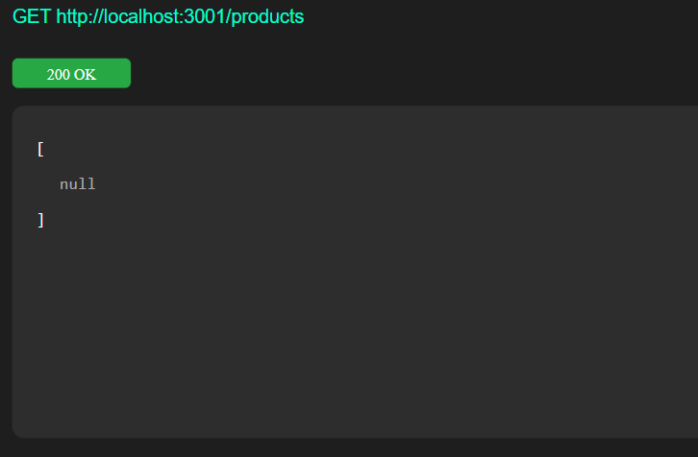
POST: http://localhost:3001/products
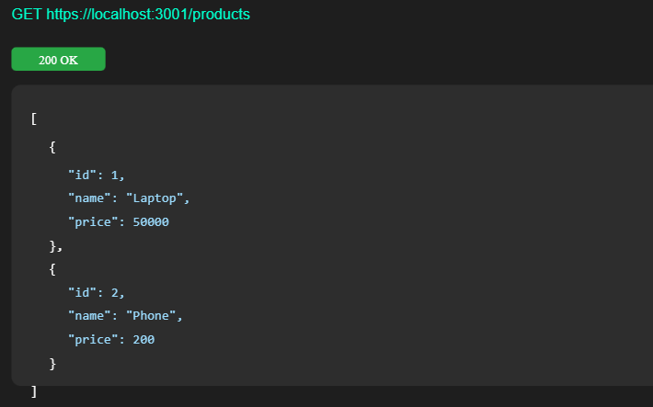
RESULTS: The application was successfully divided into independent microservices with separate responsibilities and communication via REST APIs.

TASK15: Service Registry App
Aim: To implement service registry and discovery using Node.js by dynamically registering and discovering microservices without hard-coded URLs.
ALGORITHM: 1. Start the program
2. Create a registry server
3. Store service name and URL in memory
4. Start Product Service
5. Register Product Service to registry
Program :
Server.js :
const express = require("express");
const app = express();
app.use(express.json());
// In-memory registry
let services = [];
/*
REGISTER SERVICE
Example:
{
"name": "product-service",
"url": "http://localhost",
"port": 3001
}
*/
app.post("/register", (req, res) => {
const service = req.body;
services.push(service);
console.log("Service Registered:", service);
res.send("Service Registered Successfully");
});
/*
GET ALL SERVICES
*/
app.get("/services", (req, res) => {
res.json(services);
});
/*
GET SINGLE SERVICE
*/
app.get("/services/:name", (req, res) => {
const name = req.params.name;
const service = services.find(s => s.name === name);
if (service) {
res.json(service);
} else {
res.status(404).send("Service Not Found");
}
});
/*
DELETE SERVICE
*/
app.delete("/services/:name", (req, res) => {
const name = req.params.name;
services = services.filter(s => s.name !== name);
res.send("Service Removed");
});
app.listen(4000, () => {
console.log("Service Registry running on http://localhost:4000");
});
Output :
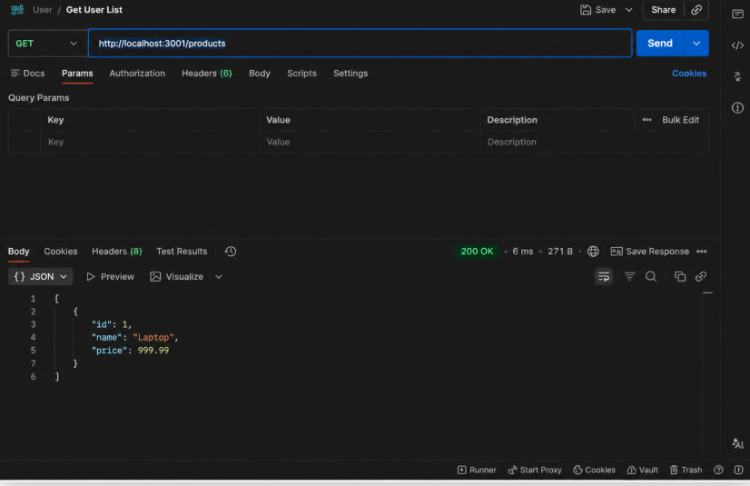
RESULT: The microservices-based system was successfully implemented with service registry and discovery, enabling dynamic communication between independent services without hard coded URLs.

TASK16: API GATEWAY API
AIM: To configure an API Gateway that routes client requests to microservices and performs basic load balancing across multiple service instances.
ALGORITHM:
1. Start the program
2. Create API Gateway server
3. Define routes for microservices
4. Create multiple instances of a service
5. Store service URLs in an array
6. Implement round-robin load balancing
7. Receive client request at gateway
8. Select service instance dynamically
9. Forward request to selected instance
10. Get response from service
11. Send response back to client
12. Stop the program
Program :
Server.js :
const express = require("express");
const axios = require("axios");
const app = express();
app.use(express.json());
// Base service URL (Product Service)
const PRODUCT_SERVICE = "http://localhost:3001/products";
/*
GET ALL PRODUCTS
*/
app.get("/products", async (req, res) => {
try {
const response = await axios.get(PRODUCT_SERVICE);
res.json(response.data);
} catch (err) {
res.status(500).send("Gateway Error");
}
});
/*
ADD PRODUCT
*/
app.post("/products", async (req, res) => {
try {
const response = await axios.post(PRODUCT_SERVICE, req.body);
res.send(response.data);
} catch (err) {
res.status(500).send("Gateway Error");
}
});
/*
GET SINGLE PRODUCT
*/
app.get("/products/:id", async (req, res) => {
try {
const response = await axios.get(
`${PRODUCT_SERVICE}/${req.params.id}`
);
res.json(response.data);
} catch {
res.status(404).send("Product Not Found");
}
});
/*
DELETE PRODUCT
*/
app.delete("/products/:id", async (req, res) => {
try {
await axios.delete(`${PRODUCT_SERVICE}/${req.params.id}`);
res.send("Product Deleted");
} catch {
res.status(404).send("Delete Failed");
}
});
app.listen(3000, () => {
console.log("API Gateway running at http://localhost:3000");
});
Output :
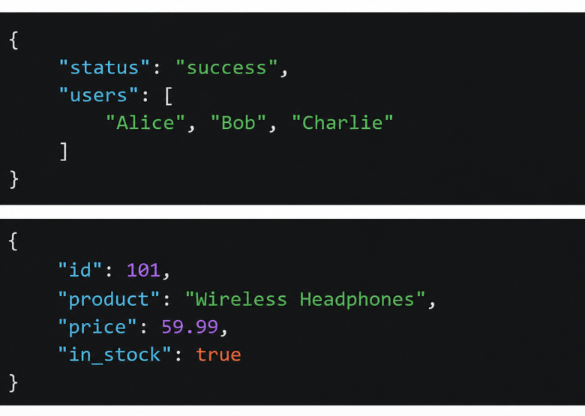
RESULT: The API Gateway was successfully implemented to route requests and distribute load across multiple service instances using round-robin load balancing.

TASK17: Inter Service App
AIM:
To enable inter-service communication where one microservice consumes another service’s REST API and handles responses and failures gracefully.
ALGORITHM:
1. Start the program
2. Create Product Service (provider)
3. Create Order Service (consumer)
4. Implement REST API in Product Service
5. Store Service product data in memory
6. Implement Order Service API
7. Use axios/fetch to call Product
8. Receive response from Product Service
FOLDER STRUCTURE:
inter-service-app/
│
├── product-service/
│ └── server.js
│ ├── order-service/
│ └── server.js
Program :
product-service:server.js
const express = require("express");
const app = express();
app.use(express.json());
// Sample Product Data
let products = [
{ id: 1, name: "Laptop", price: 50000 },
{ id: 2, name: "Phone", price: 200 }
];
// GET ALL PRODUCTS
app.get("/products", (req, res) => {
res.json(products);
});
// GET SINGLE PRODUCT
app.get("/products/:id", (req, res) => {
const product = products.find(p => p.id == req.params.id);
if (product) {
res.json(product);
} else {
res.status(404).send("Product Not Found");
}
});
app.listen(3001, () => {
console.log("Product Service running at http://localhost:3001");
});
order-service:server.js
const express = require("express");
const axios = require("axios");
const app = express();
app.use(express.json());
// CREATE ORDER (Inter-service call)
app.post("/order", async (req, res) => {
const productId = req.body.productId;
try {
// CALL PRODUCT SERVICE
const response = await axios.get(
`http://localhost:3001/products/${productId}`
);
const product = response.data;
const order = {
orderId: Math.floor(Math.random() * 1000),
productName: product.name,
price: product.price
};
res.json(order);
} catch (err) {
res.status(404).send("Product not found from Product Service");
}
});
app.listen(3002, () => {
console.log("Order Service running at http://localhost:3002");
});
Output :
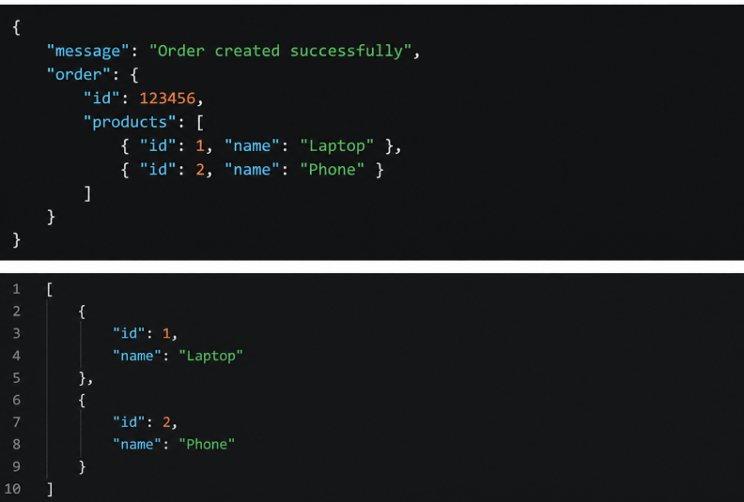
RESULT: Inter-service communication was successfully implemented using REST APIs, with proper handling of responses and failures between microservices.

TASK18: Microservice Test:
Aim :To write unit test cases for microservices to validate service logic, REST APIs, and data handling using a testing framework.
ALGORITHM:
1. Start the program
2. Install testing framework (Jest, Supertest)
3. Configure test script in package.json
4. Create test folder/files
5. Import service modules
6. Write test cases for service logic
7. Write test cases for REST APIs
8. Mock external dependencies if needed
Program :
app.js:
const express = require("express");
const app = express();
app.use(express.json());
// Sample Data
let products = [
{ id: 1, name: "Laptop", price: 50000 },
{ id: 2, name: "Phone", price: 200 }
];
// GET ALL
app.get("/products", (req, res) => {
res.json(products);
});
// GET ONE
app.get("/products/:id", (req, res) => {
const product = products.find(p => p.id == req.params.id);
if (product) {
res.json(product);
} else {
res.status(404).send("Product Not Found");
}
});
// ADD PRODUCT
app.post("/products", (req, res) => {
const newProduct = req.body;
newProduct.id = products.length + 1;
products.push(newProduct);
res.status(201).json(newProduct);
});
module.exports = app;
server.js:
const app = require("./app");
const PORT = 3001;
app.listen(PORT, () => {
console.log(`Server running on http://localhost:${PORT}`);
});
Product.Test.js :
const request = require("supertest");
const app = require("./app");
describe("Product API Test", () => {
// TEST GET ALL
test("GET /products should return all products", async () => {
const res = await request(app).get("/products");
expect(res.statusCode).toBe(200);
expect(res.body.length).toBeGreaterThan(0);
});
// TEST GET ONE
test("GET /products/1 should return product", async () => {
const res = await request(app).get("/products/1");
expect(res.statusCode).toBe(200);
expect(res.body.name).toBe("Laptop");
});
// TEST ADD
test("POST /products should add product", async () => {
const res = await request(app)
.post("/products")
.send({ name: "Tablet", price: 300 });
expect(res.statusCode).toBe(201);
expect(res.body.name).toBe("Tablet");
});
// TEST NOT FOUND
test("GET /products/999 should return 404", async () => {
const res = await request(app).get("/products/999");
expect(res.statusCode).toBe(404);
});
});
Output :
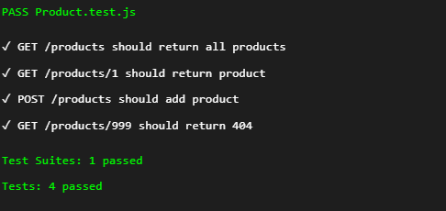
RESULT: Unit test cases were successfully implemented to validate microservice logic, REST APIs, and data handling, ensuring application reliability.

TASK19: Mini Git System
AIM: To design a simple Git-like web application that tracks file changes, stores versions, and displays commit history using HTML, CSS, JavaScript, and Node.js.
ALGORITHM:
1. Start the program
2. Create project files (HTML, CSS, JS, server.js, db.js)
3. Design UI for entering file content
4. Capture user input using JavaScript
5. Send data to server using fetch API
6. Store versions in database (array)
7. Assign version number to each commit
8. Save commit message and timestamp
9. Create API to fetch commit history
10. Display commit history in UI
Program :
Index.html :
<!DOCTYPE html>
<html>
<head>
<title>Mini Git System</title>
<link rel="stylesheet" href="style.css">
</head>
<body>
<div class="container">
<h2>Mini Git System</h2>
<!-- Commit Input -->
<input type="text" id="message" placeholder="Enter commit message">
<button onclick="addCommit()">Commit</button>
<hr>
<button onclick="getCommits()">View History</button>
<div id="output"></div>
</div>
<script src="script.js"></script>
</body>
</html>
Style.css :
body {
background: #0d1117;
color: white;
font-family: Arial;
text-align: center;
}
.container {
width: 320px;
margin: 80px auto;
background: #161b22;
padding: 20px;
border-radius: 10px;
}
input {
width: 90%;
padding: 10px;
margin: 10px;
border-radius: 5px;
border: none;
}
button {
padding: 8px 20px;
background: #238636;
color: white;
border: none;
border-radius: 5px;
}
button:hover {
background: #2ea043;
}
#output {
margin-top: 15px;
text-align: left;
font-size: 13px;
}
Script.js :
const API = "http://localhost:3000/commits";
// ADD COMMIT
function addCommit() {
const message = document.getElementById("message").value;
fetch(API, {
method: "POST",
headers: { "Content-Type": "application/json" },
body: JSON.stringify({ message })
})
.then(res => res.text())
.then(msg => {
alert(msg);
getCommits();
});
}
// GET COMMITS
function getCommits() {
fetch(API)
.then(res => res.json())
.then(data => {
let output = "<pre>" + JSON.stringify(data, null, 2) + "</pre>";
document.getElementById("output").innerHTML = output;
});
}
DB.js :
let commits = [];
// ADD COMMIT
function addCommit(data, cb) {
const commit = {
id: commits.length + 1,
message: data.message,
time: new Date().toLocaleString()
}
commits.push(commit);
cb(null, commit);
}
// GET COMMITS
function getCommits(cb) {
cb(null, commits);
}
module.exports = { addCommit, getCommits };
Output :
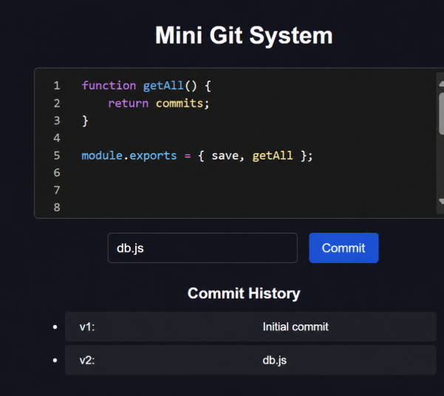
RESULT: A mini Git-like system was successfully developed to track versions, store commits, and display history through a web interface.

TASK20: Mini Git Branch App
Aim: To develop a Git-like application that supports branching, merging, rebasing, and conflict resolution using a web interface.
ALGORITHM:
1. Start the program
2. Create project files (HTML, CSS, JS, server.js, db.js)
3. Store branches and commits in memory
4. Create default branch (main)
5. Add feature to create new branch
6. Commit changes to selected branch
7. Implement merge logic
8. Detect conflicts (same file modified)
Program :
Index.html :
<!DOCTYPE html>
<html>
<head>
<title>Mini Git Branch</title>
<link rel="stylesheet" href="style.css">
</head>
<body>
<div class="box">
<h3>Mini Git Branch</h3>
<input id="branch" placeholder="Branch name">
<input id="msg" placeholder="Commit message">
<button onclick="add()">Commit</button>
<button onclick="view()">History</button>
<div id="out"></div>
</div>
<script src="script.js"></script>
</body>
</html>
Style.css:
body {
background:#1e1e2f;
color:white;
text-align:center;
font-family:Arial;
}
.box {
margin:80px auto;
width:250px;
background:#2d2d44;
padding:15px;
border-radius:10px;
}
input {
width:90%;
margin:5px;
padding:8px;
}
button {
margin:5px;
padding:6px 15px;
background:#00bcd4;
color:white;
border:none;
}
SCRIPT.JS:
const API = "http://localhost:3000";
function add() {
fetch(API + "/commit", {
method:"POST",
headers:{ "Content-Type":"application/json" },
body: JSON.stringify({
branch: branch.value,
msg: msg.value
})
}).then(()=>view());
}
function view() {
fetch(API + "/commits")
.then(r=>r.json())
.then(d=>{
out.innerHTML = "<pre>"+JSON.stringify(d,null,2)+"</pre>";
});
}
SERVER.JS:
const express = require("express");
const cors = require("cors");
const db = require("./db");
const app = express();
app.use(cors());
app.use(express.json());
app.post("/commit", (req,res)=>{
db.add(req.body, ()=>res.send("Added"));
});
app.get("/commits", (req,res)=>{
db.get((_,data)=>res.json(data));
});
app.listen(3000, ()=>console.log("Server running"));
DB.JS:
let commits = [];
exports.add = (data, cb) => {
commits.push({
id: commits.length+1,
branch: data.branch,
msg: data.msg
});
cb(null);
};
exports.get = (cb) => cb(null, commits);

Output :
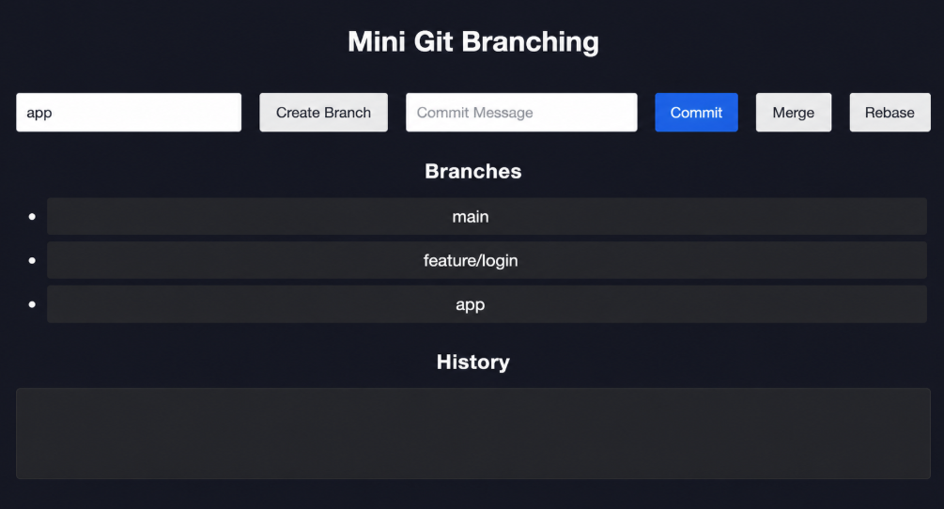
RESULT: A Git-like branching application was successfully developed to simulate branching, merging, rebasing, and conflict resolution through a web interface.

TASK21: Mini Cicd App
AIM:
To develop a CI/CD pipeline simulation application that automates build, test, and deployment steps through a web interface.
ALGORITHM:
- Start the program
- Create project files (ML, CSS, JS, server.js, db.js)
- Design UI for pipeline trigger
- Capture user action (Run Pipeline)
- Send request to backend
- Simulate code checkout step
7. Simulate build process
8. Simulate test execution
9. Simulate deployment step
10. Store pipeline logs
11. Display pipeline status in UI
12. Stop the program
Program :
Index.html:
<!DOCTYPE html>
<html>
<head>
<title>Mini CI/CD App</title>
<link rel="stylesheet" href="style.css">
</head>
<body>
<div class="box">
<h3>Mini CI/CD Pipeline</h3>
<button onclick="run('Build')">Build</button>
<button onclick="run('Test')">Test</button>
<button onclick="run('Deploy')">Deploy</button>
<div id="out"></div>
</div>
<script src="script.js"></script>
</body>
</html>
Style.css :
body {
background:#1e1e2f;
color:white;
text-align:center;
font-family:Arial;
}
.box {
margin:100px auto;
width:260px;
background:#2d2d44;
padding:20px;
border-radius:10px;
}
button {
margin:5px;
padding:8px 15px;
background:#00bcd4;
color:white;
border:none;
border-radius:5px;
}
#out {
margin-top:15px;
font-size:14px;
}
Script.js :
function run(step) {
const out = document.getElementById("out");
out.innerHTML = step + " started...";
setTimeout(() => {
out.innerHTML = step + " successful ✅";
}, 1500);
}
Output :
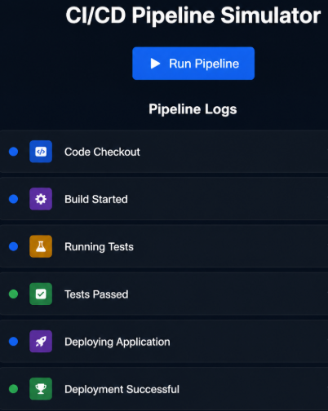
RESULT: A CI/CD pipeline simulation application was successfully developed to automate and visualize build, test, and deployment processes.

TASK22: Cloud App
AIM: To develop a cloud comparison application that displays and compares services and pricing models of AWS, GCP, and Azure.
ALGORITHM:
1. Start the program
2. Create project files (HTML, CSS, JS, server.js, db.js)
3. Design user interface with dropdown for cloud providers
4. Initialize cloud service data (AWS, GCP, Azure) in database module
5.Capture selected provider using JavaScript
6. Send request to server to fetch service details
7. Display compute, storage, database, and networking services
8. Accept user input for compute hours and storage usage
9. Send input data to server for cost calculation
10. Calculate cost based on pay-as-you-use pricing model
Program :
Index.html :
<!DOCTYPE html>
<html>
<head>
<title>Cloud App</title>
<link rel="stylesheet" href="style.css">
</head>
<body>
<div class="box">
<h3>Cloud Storage App</h3>
<input id="name" placeholder="Enter Name">
<input id="data" placeholder="Enter Data">
<button onclick="save()">Save</button>
<button onclick="load()">Load</button>
<div id="out"></div>
</div>
<script>
const API = "http://localhost:3000";
function save() {
fetch(API + "/save", {
method:"POST",
headers:{ "Content-Type":"application/json" },
body: JSON.stringify({
name: name.value,
data: data.value
})
}).then(()=>load());
}
function load() {
fetch(API + "/data")
.then(r=>r.json())
.then(d=>{
out.innerHTML = "<pre>"+JSON.stringify(d,null,2)+"</pre>";
});
}
</script>
</body>
</html>
Style.css :
body {
background:#1e1e2f;
color:white;
text-align:center;
font-family:Arial;
}
.box {
margin:80px auto;
width:260px;
background:#2d2d44;
padding:20px;
border-radius:10px;
}
input {
width:90%;
margin:5px;
padding:8px;
}
button {
margin:5px;
padding:6px 15px;
background:#00bcd4;
color:white;
border:none;
}
#out {
margin-top:15px;
font-size:13px;
}
Server.js :
const express = require("express");
const cors = require("cors");
const db = require("./db");
const app = express();
app.use(cors());
app.use(express.json());
// SAVE DATA
app.post("/save", (req, res) => {
db.save(req.body, () => res.send("Saved to Cloud"));
});
// GET DATA
app.get("/data", (req, res) => {
db.get((_, data) => res.json(data));
});
app.listen(3000, () => console.log("Cloud App running"));
DB.js :
let storage = [];
exports.save = (data, cb) => {
storage.push({
id: storage.length + 1,
name: data.name,
data: data.data
});
cb(null);
};
exports.get = (cb) => {
cb(null, storage);
};
Output :
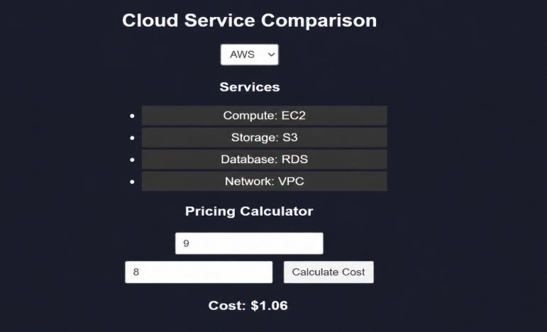
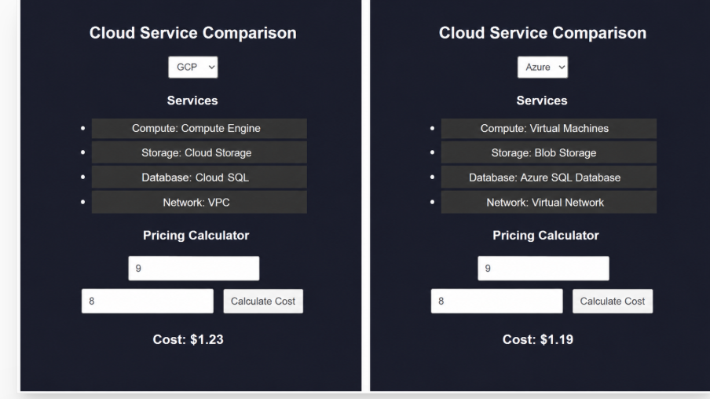
RESULTS: A cloud comparison application was successfully developed to display services and simulate pay-as-you-use pricing across AWS, GCP, and Azure.

TASK23: AI PROMPT APP
AIM: To develop an application that demonstrates prompt engineering by generating and evaluating code or cloud configurations based on user input.
ALGORITHM:
1. Start the program
2. Create project files (HTML, CSS, JS, server.js, db.js)
3. Design UI with input field for user prompt
4. Capture user prompt using JavaScript
5. Send prompt to server using fetch API
6. Receive prompt data in backend (server.js)
7. Process prompt using predefined logic (db.js)
8. Generate output (code / cloud config / response)
9. Evaluate output quality and assign score
10. Send generated output and score to frontend
Program :
Index.html :
<!DOCTYPE html>
<html>
<head>
<title>AI Prompt App</title>
<link rel="stylesheet" href="style.css">
</head>
<body>
<div class="box">
<h3>AI Prompt App</h3>
<input id="prompt" placeholder="Enter your prompt">
<button onclick="send()">Ask AI</button>
<div id="out"></div>
</div>
<script src="script.js"></script>
</body>
</html>
Style.css :
body {
background:#1e1e2f;
color:white;
text-align:center;
font-family:Arial;
}
.box {
margin:100px auto;
width:280px;
background:#2d2d44;
padding:20px;
border-radius:10px;
}
input {
width:90%;
padding:8px;
margin:10px;
}
button {
padding:8px 15px;
background:#00bcd4;
color:white;
border:none;
}
#out {
margin-top:15px;
font-size:14px;
}
Script.js:
const API = "http://localhost:3000/ask";
function send() {
fetch(API, {
method:"POST",
headers:{ "Content-Type":"application/json" },
body: JSON.stringify({ prompt: prompt.value })
})
.then(r=>r.json())
.then(d=>{
out.innerHTML = "<b>AI:</b> " + d.reply;
});
}
DB.js:
let history = [];
exports.save = (data, reply, cb) => {
history.push({
id: history.length+1,
prompt: data.prompt,
reply: reply
});
cb(null);
};
exports.get = (cb) => cb(null, history);
Server.js:
const express = require("express");
const cors = require("cors");
const db = require("./db");
const app = express();
app.use(cors());
app.use(express.json());
// FAKE AI RESPONSE
function generateReply(prompt) {
return "AI Response to: " + prompt;
}
// ASK AI
app.post("/ask", (req,res)=>{
const reply = generateReply(req.body.prompt);
db.save(req.body, reply, ()=> {
res.json({ reply });
});
});
// GET HISTORY
app.get("/history", (req,res)=>{
db.get((_,data)=>res.json(data));
});
app.listen(3000, ()=>console.log("AI App running"));
Output :
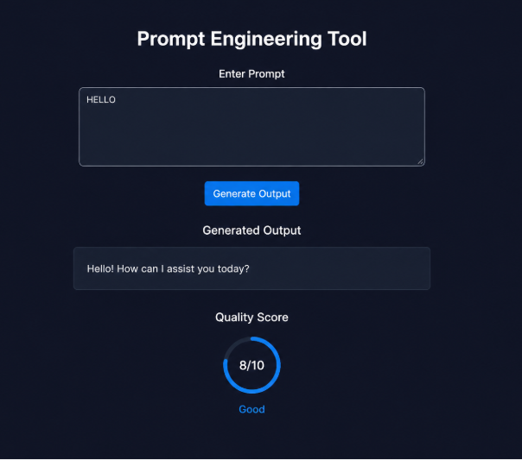
RESULT: A prompt engineering application was successfully developed to generate and evaluate AI-based outputs for code and cloud configurations.

TASK24: Vibe Cloud App
AIM: To develop an application that uses iterative prompt engineering to generate and evaluate REST APIs, cloud deployment steps, and security configurations.
ALGORITHM:
1. Start the program
2. Create project files (HTML, CSS, JS, server.js, db.js)
3. Design UI to accept user prompts
4. Capture prompt input using JavaScript
5. Send prompt to backend using fetch API
6. Receive prompt in server and forward to processing module
7. Store prompt in history for version tracking
8. Analyze prompt type (REST API / Cloud / Security)
9. Generate corresponding output based on prompt
10. Evaluate output quality and assign score
11. Return output and score to frontend and display results
12. Stop the program
PROGRAM:
INDEX.HTML:
<!DOCTYPE html>
<html>
<head>
<title>Vibe Cloud App</title>
<link rel="stylesheet" href="style.css">
</head>
<body>
<div class="card">
<h2>☁️ Vibe Cloud</h2>
<input id="title" placeholder="Title">
<input id="content" placeholder="Content">
<button onclick="save()">Save</button>
<button onclick="load()">Load</button>
<div id="out"></div>
</div>
<script src="db.js"></script>
<script src="script.js"></script>
</body>
</html>
Style.css :
body {
background: linear-gradient(135deg, #1e1e2f, #3a3a6a);
font-family: Arial;
text-align: center;
color: white;
}
.card {
width: 280px;
margin: 100px auto;
padding: 20px;
background: rgba(255,255,255,0.1);
border-radius: 15px;
backdrop-filter: blur(10px);
}
input {
width: 90%;
padding: 8px;
margin: 8px;
border-radius: 5px;
border: none;
}
button {
margin: 5px;
padding: 8px 15px;
background: #00bcd4;
border: none;
color: white;
border-radius: 5px;
}
#out {
margin-top: 15px;
font-size: 13px;
}
Script.js :
function save() {
const data = {
title: title.value,
content: content.value
};
addData(data);
load();
}
function load() {
getData((d) => {
out.innerHTML = "<pre>" + JSON.stringify(d, null, 2) + "</pre>";
});
}
DB.js :
let cloud = [];
function addData(data) {
cloud.push({
id: cloud.length + 1,
title: data.title,
content: data.content
});
}
function getData(cb) {
cb(cloud);
}
Output :
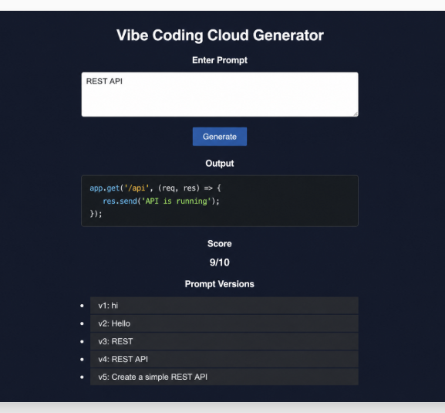 RESULT: A Vibe Coding application was successfully developed to generate and refine cloud based features using iterative prompt engineering.

